Dear Parent/Carer,

I am delighted to hear that your son/daughter has shown an interest in our exciting new WEST END WORKSHOP event. This day caters for all abilities and interests and will develop your child’s performance skills in Acting, Dancing and Singing. At this event, your child will experience a Musical Theatre workshop taught by a current West End star based on the wonderful musical WICKED! They will also have a chance to ask our West End Star a few questions about how they managed to break through into the West End.

Our West End star this time is Chiarina Woodall; I will be assisting on the event. It will be delivered at The Exchange, 75 London Road, Twickenham. TW1-1BE.

The WEST END WORKSHOP will run on Sunday 16th February 2020 from 11am-2pm.

WEST END WORKSHOP DAY: 11am-2pm**
Price: £25.00

All participants must be 7+ in order to attend. The structure of the day will see the children warm-up through interactive games and dance. There will be a 15-minute break for a snack/light lunch within the day.
**Please note; there will not be a sharing at the end of the day.

Either way if your child is new to the Arts or has plentiful experience then please sign them up for a fun and enjoyable time with Boundless Dance. Please make sure your child’s attire is something they can move easily in, and they will be bare foot during the practical sessions. No skirts or dresses to be worn. The participants will also be requiring a packed lunch (no nuts) and soft drink preferably in a bottle that can be filled with water throughout the day; no glass bottles please.

If you have any further questions please do not hesitate to contact us on 07951 305935 or email info@boundlessdance.co.uk.

I look forward to seeing you guys at the WEST END WORKSHOP.

Kind regards, Lee Lee Harvey Robinson, (Founder of Boundless)
WEST END WORKSHOP REGISTRATION FORM – JAN’ 20
- The Exchange, Twickenham -

I would like my son/daughter to attend the WEST END WORKSHOP delivered by Boundless on Sunday 16th February 2020 from 11am till 2pm.

ACRO SKILLS WORKSHOP only 10am-2pm - £25 -

* cheques made payable to Mr L Robinson
* BACS transfer: Details on request

NAME OF CHILD:

AGE OF CHILD:

EMERGENCY CONTACT NAME:

EMERGENCY CONTACT NUMBER:

EMAIL ADDRESS:

MEDICAL NEEDS:

I GIVE PERMISSION FOR PHOTOGRAPHS AND VIDEOS OF MY CHILD TO BE USED BY BOUNDLESS
FOR PUBLICITY PURPOSES
YES / NO
I GIVE PERMISSION FOR MINE AND MY CHILD’S DETAILS TO BE KEPT ON FILE BY BOUNDLESS; THIS INCLUDES FOR EMERGENCY CONTACT PURPOSES
YES / NO

Please return this registration form, via email to info@boundlessdance.co.uk
VENUE DETAILS
THE EXCHANGE,
75 LONDON ROAD, TWICKENHAM. TW1-1BE

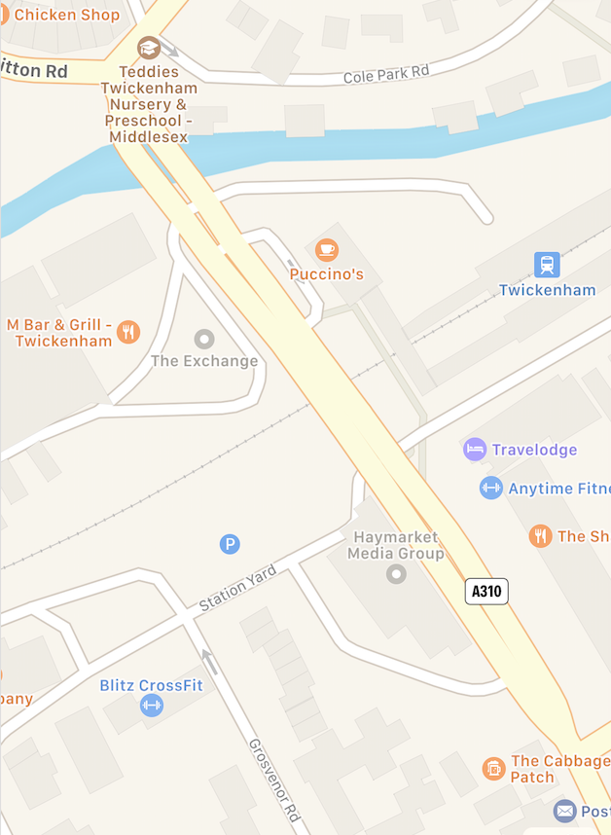
THE EXCHANGE
PUBLIC TRANSPORT:
By Train: The closest Train Station is Twickenham BR. Please see www.maps.google.com for exact directions on how to access The Exchange from the station. The walking time from the station is around 1 minute.

By Bus: 110, 267, 281 buses pass right outside The Exchange.

By Car: Unfortunately, there is no public parking at The Exchange. There are limited parking spaces near the venue for Blue Badge holders. There are public car parks in Twickenham within walking distance of the venue.

Walking: Please visit www.maps.google.com for more information on this.

