Dear Parent/Carer,

I am very pleased to hear your son/daughter has shown an interest in the extremely enjoyable ACTIVITY WORKSHOP WEEK with Matt and Lee

The fun filled workshops cater for all abilities and will develop your child’s aptitude in the three main genres of performance; Acting, Dancing and Singing. It will be delivered at Carlisle Infant School, Broad Lane, Hampton. TW12-3AJ.

The ACTIVITY WORKSHOP WEEK will run from Monday 7th August to Friday 11th August 2017 between the hours of 10am till 3pm.
.

The charge for the ACTIVITY WORKSHOP WEEK is as follows:

£30 for 1DAY, £55 for 2DAYS, £20 per day for 3DAYS or more

Every day the performers will experience an array of workshops including acting, dancing, singing, creativity, skills and much more. The workshops will aid personal performance and creativity development, as well as confidence building exercises and social interactions.

*Please note there is no performance during this event; there will be small sharing’s of the work produced amongst the participants.

Either way if your child is new to the Arts or has plentiful experience then please sign them up for a fun and enjoyable time with Boundless. Please make sure your child’s attire is something they can move in easily. They will also be requiring a packed lunch and soft drink (preferably in a bottle that can be filled with water throughout the day); no glass bottles please.

If you have any further questions please do not hesitate to contact me on 07951 305935 or email me at info@boundlessdance.co.uk.

We shall look forward to seeing your budding performer(s) at the ACTIVITY WORKSHOP WEEK.

Kind regards,
Lee & Matt

Lee Harvey Robinson
-Artistic Director of Boundless Dance-

- ACTIVITY WORKSHOP WEEK REGISTRATION FORM -
AUGUST 2017
-Carlisle Infant School, Hampton-

I would like my child to attend the ACTIVITY WORKSHOP WEEK delivered by Boundless from 7th-11th August 2017 from 10am-3pm.

I ENCLOSE PAYMENT OF (please circle accordingly):
£30 for 1Day: Monday – Tuesday – Wednesday – Thursday – Friday

£55 for 2Days: Monday – Tuesday – Wednesday – Thursday – Friday

£20 per day for 3 or more days:
Monday – Tuesday – Wednesday – Thursday – Friday

* CHEQUES: Please make payable to Mr. L Robinson
* BACS TRANSFER: Please e-mail Boundless Dance asking for these details.

NAME OF CHILD: ________________________________________________________________

AGE OF CHILD: ___________________________________________________________________

GENDER: __________________________________________________________________________

EMERGENCY CONTACT NAME: ________________________________________________

EMERGENCY CONTACT NUMBER: _____________________________________________

E-MAIL ADDRESS: _______________________________________________________________

Please make Boundless aware of any medical needs your child may have:

- Please return this Registration Form either by e-mail or to Boundless Dance, Attn: Mr. L Robinson, 58 Queens Road, Mortlake, Surrey, London. SW14 8PJ
VENUE DETAILS

CARLISLE INFANT SCHOOL, BROAD LANE, HAMPTON. TW12 3AJ

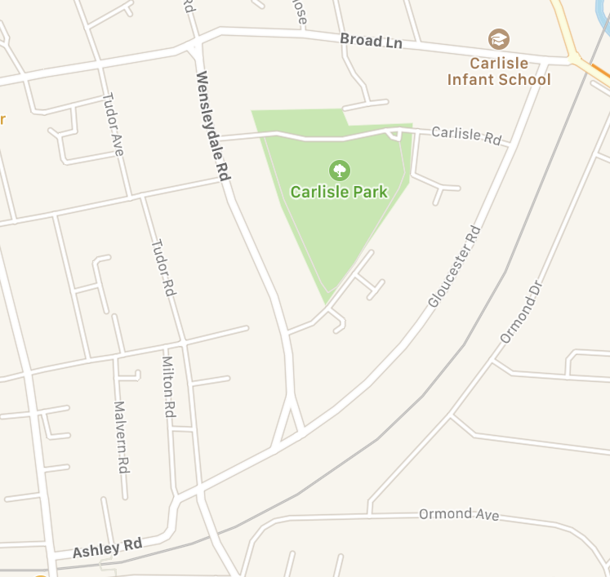
HAMPTON STATION

PUBLIC TRANSPORT:

By Train: Closest Train Station is Hampton. Please exit Hampton Station onto Ashley Road, turn right & follow Ashley Road toward Hampton Village and onto Wensleydale Road. If you continue down Wensleydale Road (which turns into Gloucester Road) for 15 minutes you will meet Broad Lane, please turn left onto Broad Lane & you will see Carlisle Infant School on your right a few yards up.

By Bus: Take routes 285 and R68.

By Car: You can park on the road outside the school and in surrounding roads.

Walking: Please visit www.maps.google.com for more information on this.

